**IT8701 Introduction to Programming for Data Science**

**Practical 1 – Submission Question**

### Task 4: Average of electricity bills (SUBMISSION REQUIRED)

Write a Python program that prompts the user to enter his electricity bill for the last 6 months and prints out the average of his electricity bills as shown below.

Hint -- > Remember to convert your inputs to datatype float before performing calculations!

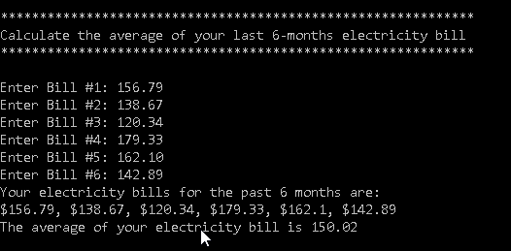

### Task 2: Perform simple string operations (SUBMISSION REQUIRED)

Write a Python program to achieve the following:

1. prompt the user to enter 3 random strings of at least 8 characters long, each separated by a comma

A sample of what the user might enter is given below

*When Breath Becomes Air,The 91-Storey Treehouse,Harry Potter and the Prisoner of Azkaban*

1. use the **split()** function in Python to separate the strings and store the separated strings into three variables, s1, s2 and s3
2. Perform the following operations on each string:

* calculate the length of each string
* extract the 2nd and third characters of s1, fifth to seven characters of s2 and last two characters of s3
* Your output should look similar to that as shown below.

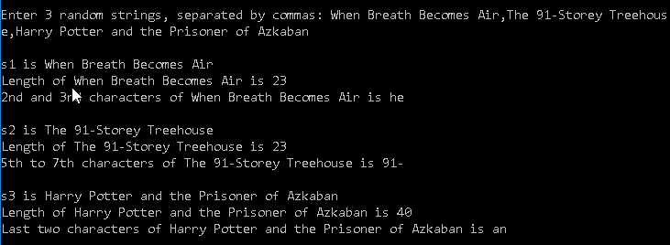

### Task 2: Spdonalds (SUBMISSION REQUIRED)

Write a Python program that displays a breakfast menu to the user, asks him for the food he wants to buy and calculates the amount he must pay for the food

Your program should:

1. show the user a menu consisting of the breakfast menu choices as shown in Fig. 1+2
2. prompt the user to enter his breakfast choice
3. Display and error message and terminate the program if the choice is invalid
4. If breakfast choice is valid, prompt him to enter the quantity he wants to buy
5. calculate and display the total amount he must pay

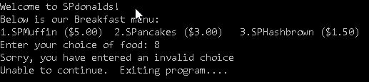

Figure 4: Invalid input

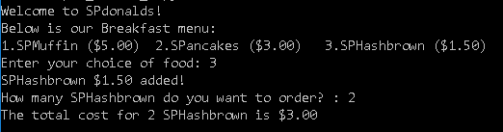

Figure 5: Valid input

### Task 2: Calculate sum of numbers within a range (SUBMISSION REQUIRED)

Write a Python program that calculates the sum of all the numbers from x to y, where x and y are numbers entered by the user.

Your program should:

1. Inform the user the purpose of the program as shown in the screenshot below
2. Prompt the user to enter the value for x and y.
3. check if 1) x and y are numeric 2) higher than zero 3) y is greater than x. If not, display an error message and terminate the program.
4. Use a **for** loop to calculate the sum of numbers from x to y and store the final value in the variable sum_of_numbers
5. display sum_of_numbers to the user

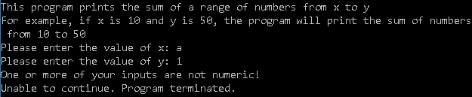

Figure 6: User did not enter numbers for x and y

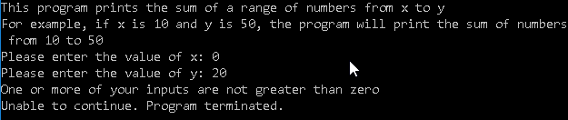

Figure 7: User did not enter numbers greater than zero for x and y

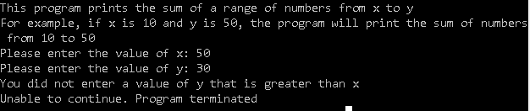

Figure 8: User did not enter y greater than x

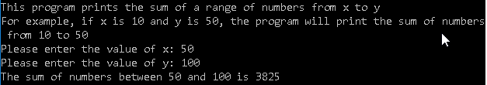

Figure 9: Print sum of numbers to user

### Task 2: Odd and Even (SUBMISSION REQUIRED)

Write a Python function that takes in a list of numbers, and outputs them into two lists, one consisting of even numbers, and the other odd numbers.

Your program should:

1. Generate a list with 100 random numbers in the range of 1 to 1000 and store them in the variable original_list. Hint: You can generate a list of numbers using list comprehension and the random.randint() function

Example:

# Generate 1000 numbers from 1 to 10

numbers = [random.randint(1,10) for x in range(0,1000)]

1. Define a function called ***oddandeven(numbers_list)*** that takes in one parameter of type list containing a list of numbers and returns two outputs of two lists, one that contains even numbers, and the other that contains odd numbers
2. After writing your function, call the ***oddandeven(numbers_list)*** function, passing in original_list as the parameter, and storing the outputs of the function as even_numbers and odd_numbers respectively
3. Print out the contents of even_numbers and odd_numbers as shown in the output below

|  |
| --- |
|  |